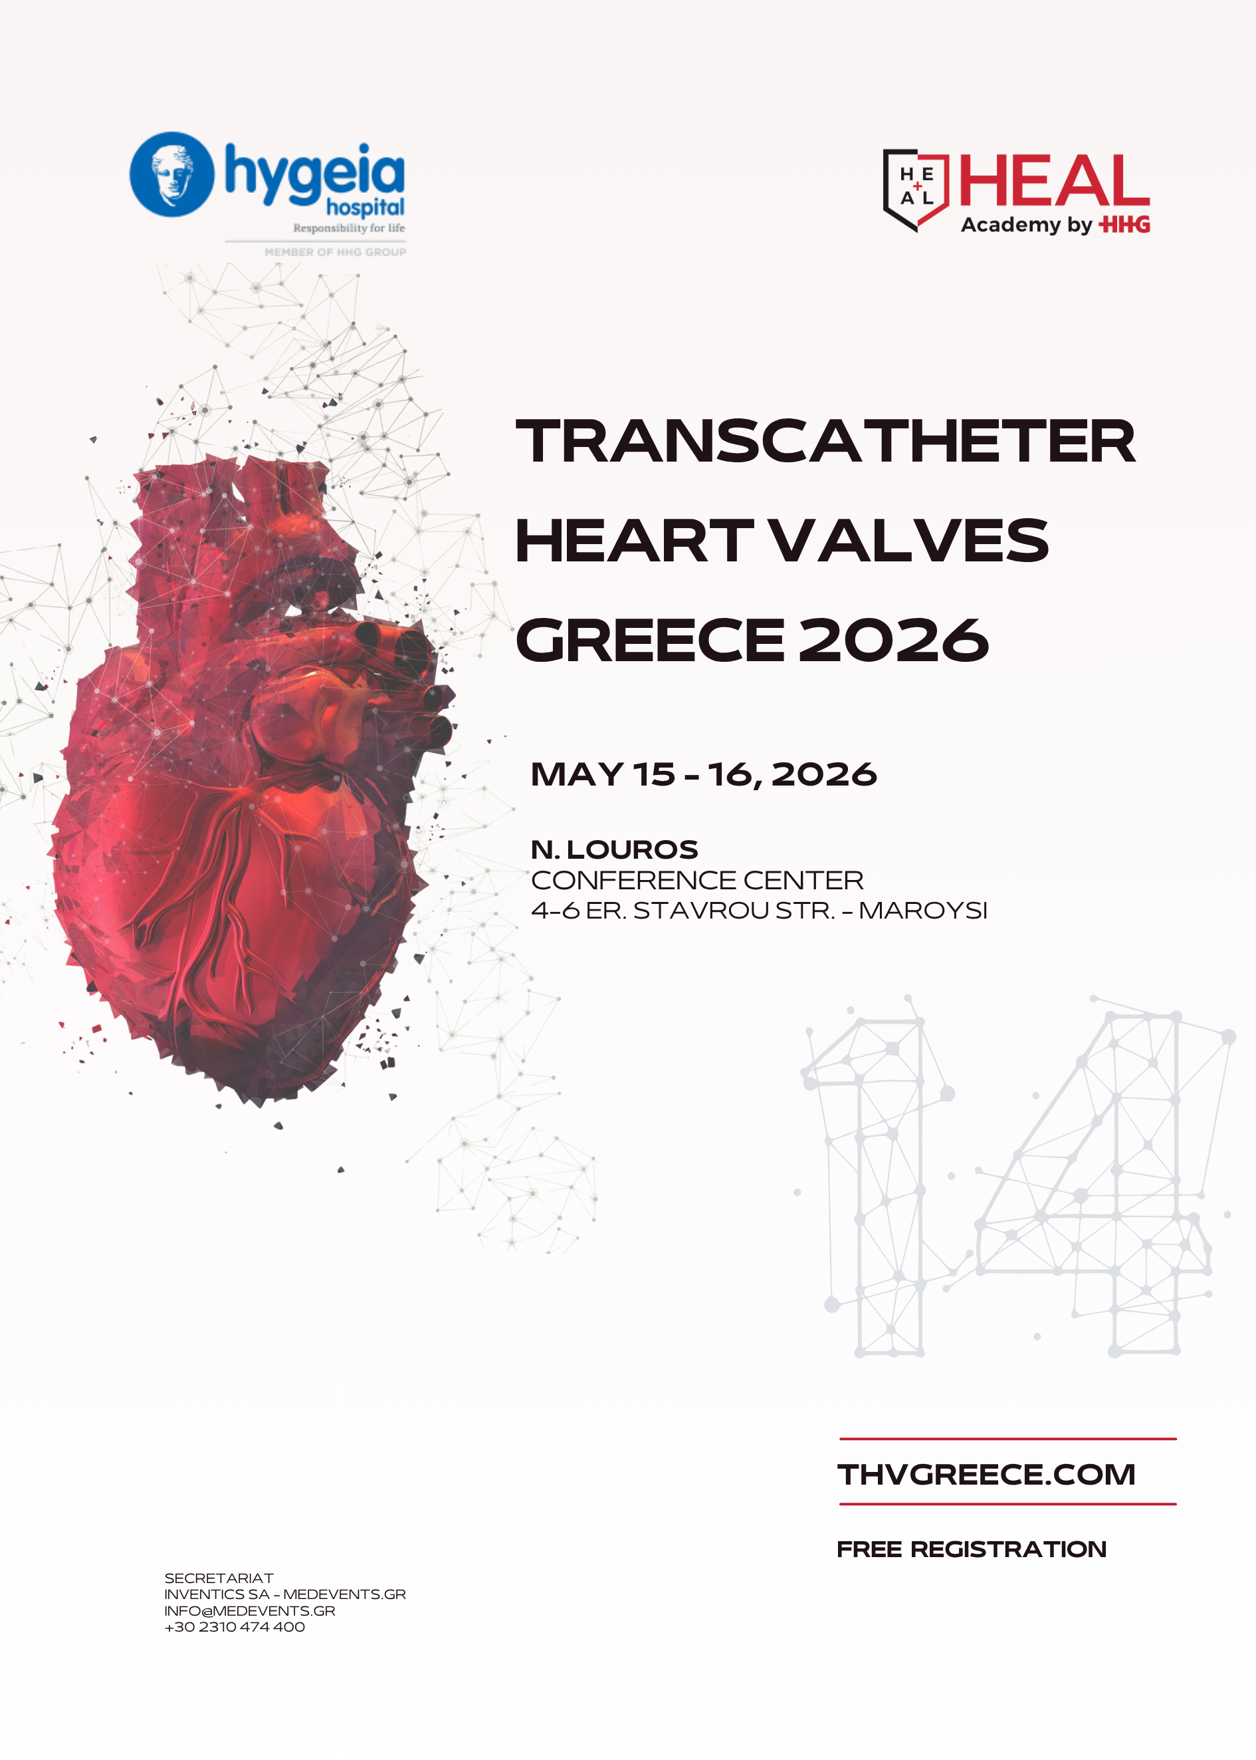
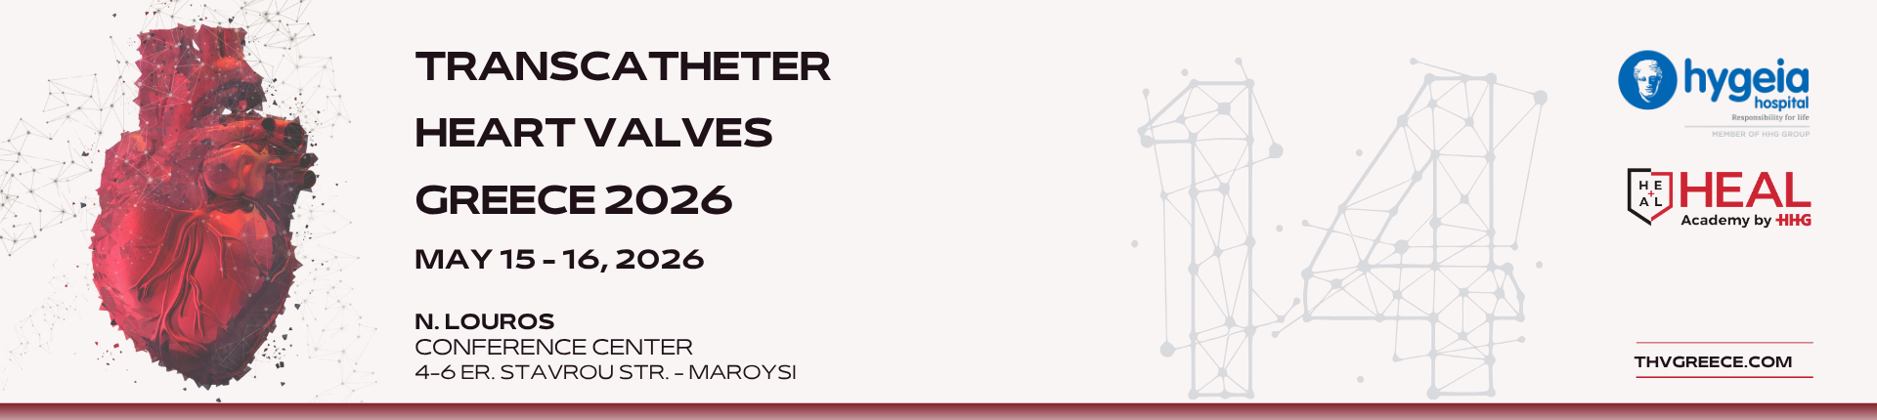
The leading international meeting for Transcatheter Heart Valve Therapies in Greece
Sessions | Transcatheter Heart Valves Greece 2026

May 15 - 16, 2026, Athens Greece
On-site conference
Venue: N. Louros Conference Center, (4-6 Er. Stavrou Str., Marousi)
Organizers: Transcatheter Heart Valves Department, HYGEIA Hospital, Athens, Greece
COURSE DIRECTORS
Stratis Pattakos Cardiac Surgeon, 2nd Cardiac Surgery Department, HYGEIA Hospital, Athens
Konstantinos Spargias MD, PhD, FESC, Interventional Cardiologist, Director,
Transcatheter Heart Valves Department, HYGEIA Hospital, Athens
Panos Vardas Emeritus Professor of Cardiology, Chairman of Heart Sector HYGEIA Hospitals Groups, President of the European Society of Cardiology (2012-2014)
PROGRAM COORDINATOR
Konstantinos Stathogiannis MD, PHD, Interventional Cardiologist, Transcatheter Heart Valves Department, HYGEIA Hospital, Athens
ORGANIZING COMMITTEE
Michael Chrissoheris Cardiologist, Associate Director, Transcatheter Heart Valves Department, HYGEIA Hospital, Athens
Gregory Pattakos Cardiac Surgeon, Director, 2nd Dept of Cardiac Surgery, Assistant Director, Transcatheter Heart Valves Department, HYGEIA Hospital, Athens
Konstantinos Stathogiannis MD, PHD, Interventional Cardiologist, Transcatheter Heart Valves Department, HYGEIA Hospital, Athens
Kyriakos Katsianos Dr. med. Interventional Cardiologist, Associate Director, Transcatheter Heart Valves Department, HYGEIA Hospital, Athens
Panagiota Kourkoveli Cardiologist, MD, PhD, FHFA, Associate Director, Transcatheter Heart Valves Department, HYGEIA Hospital, Athens
Dionysios Aravantinos Cardiologist, Transcatheter Heart Valves Department, HYGEIA Hospital, Athens
Nick Bouboulis MD, MSc, PhD, FETCS, Cardiac Surgeon, HYGEIA Hospital, Athens

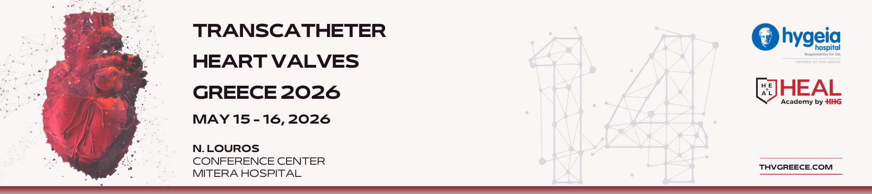
09.00-09.15 Opening & Registration
Friday May 15, 2026 | AORTIC VALVE, LEFT-SIDED & BEYOND VALVES

09:15–10:15 SESSION 1
AORTIC STENOSIS 2026: WHO SHOULD WE TREAT?
Moderators: A. Trikas, S. Pattakos
Case-based discussions
- Moderate AS + EF 35%: Intervene or observe?
D. Tziakas
Comments by panelist
C. Chrysohoou
- Low-Flow Low-Gradient AS with discordant Echo & CT
A. Zacharoulis
Comments by panelist
A. Krommydas
- Severe AS, minimal symptoms, high calcium
ΤΒΑ
Comments by panelist
K. Perreas
- The 88-Year-old patient: Benefit or futility?
A. Rigopoulos
Comments by panelist
M.-K. Konstantinidou
10:15–10:30 Opening Remarks
A. Kartapanis - Chairman & CEO, Hygeia Hospital
S. Pattakos – Surgical Director of THV
K. Spargias – Medical Director of THV
T. Skandalakis – President of the Heal Academy
Friday May 15, 2026 | AORTIC VALVE, LEFT-SIDED & BEYOND VALVES

10:30–10:45 Coffee Break
10:45–11:45 SESSION 2
TAVI PLANNING
Moderators: K. Tsioufis, P. Vardas
Case-based discussions
- Borderline annulus: 23 or 26?
K. Lampropoulos
Comments by panelist
C. Pappas
- Low coronaries and small sinuses
M. Zairis
Comments by panelist
A. Tsolakis
- Valve-in-valve with coronary risk
K. Spargias
Comments by panelist
M. Hamilos
- Bicuspid valve
G. Katsimagklis
Comments by panelist
K. Katsianos
11:45–12:15 LIVE-IN-A-BOX SESSION I — AORTIC
Moderator: G. Dangas
Panelists: A. Kalogeropoulos, A. Synetos, G. Tsigkas, G. Triantis
Friday May 15, 2026 | AORTIC VALVE, LEFT-SIDED & BEYOND VALVES

12:15–12:45 INDUSTRY TECHNOLOGY SESSION I
Moderator: K. Spargias
12:45–13:30 Lunch Break
13:30–14:15 SESSION 3
DEVICE & ACCESS STRATEGY IN TAVI
Moderators: A. Manginas, D. Stakos
Case-based discussions
- Balloon vs self-expandable in similar anatomy
K. Triantafyllou
Comments by panelist
N. Kafkas
- High pacemaker-risk patient
G. Karamasis
Comments by panelist
K. Aronis
- Alternative access that changed outcome
G. Georgiou
Comments by panelist
K. Kalogeras

14:15–14:45 LIVE-IN-A-BOX SESSION II – AORTIC
Moderator: D. Syrseloudis
Panelists: F. Kolokathis, G. Kassimis, I. Karabinos, J. Kanakakis

Friday May 15, 2026 | AORTIC VALVE, LEFT-SIDED & BEYOND VALVES

14:45–15:00 Coffee Break
15:00–15:45 SESSION 4
WHEN SURGERY STILL MATTERS: AORTIC VALVE
Moderators: C. Kotoulas, G. Filippatos
Case-based discussions
- Failed TAVI referred for SAVR
A. Roubelakis
Comments by panelist
E. Poulidakis
- TAVI explantation: When and how?
D. Avgerinos
Comments by panelist
L. Poulimenos
- Rising gradients after TAVI: Redo-TAVI or surgery?
A. Taleb
Comments by panelist
P. Koutrolou
- Post-TAVI endocarditis
D. Iliopoulos
Comments by panelist
E. Tsougkos

15:45–16:15 INDUSTRY TECHNOLOGY SESSION II
Moderator: K. Spargias

Friday May 15, 2026 | AORTIC VALVE, LEFT-SIDED & BEYOND VALVES

16:15–17:00 SESSION 5 — STRUCTURAL HEART BEYOND VALVES
Moderators: F. Mitropoulos, S. Papaioannou
Case-based discussions
- PFO Closure: To close or not to close?
A. Mitsis
Comments by panelist
K. Dimitriadis
- ASD in the adult patient: Close or observe?
A. Tzifa
Comments by panelist
I. Darladimas
- LAAO in high bleeding risk: Device or medical therapy?
A. Tzikas
Comments by panelist
M. Didaggelos
- Acute pulmonary embolism: Is cath lab the answer?
G. Latsios
Comments by panelist
A. Triantafyllis

17:00–17:15 Coffee Break
17:15–18:15 SESSION 7 — STRUCTURAL INTERVENTIONS-HEART TEAM
Moderators: N. Pilatis, V. Tzifos
Panelists: A. Karanasos, S. Makrygiannis, G. Tzanis, G. Gavrielatos
Mediteraneo Hospital
C. Psathas (TBC)
Friday May 15, 2026 | AORTIC VALVE, LEFT-SIDED & BEYOND VALVES

Athens Naval Hospital
A. Mastrokostopoulos
Athens Medical Center
A. Chalapas
HYGEIA Hospital
M. Koutouzis
St. Luke's Hospital
D. Tsikaderis
Sotiria Hospital
K. Kalogeras
18:15-19.15 SESSION 8 — STRUCTURAL INTERVENTIONS-HEART TEAM
Moderators: I. Zarifis, A. Ziakas
Panelists: G. Trantalis, G. Gavrielatos, P. Bounas, (TBC) D. Karatzas (TBC)
General Clinic
Α. Kapetanopoulos
"George Papanikolaou" General Hospital of Thessaloniki
V. Tzalamouras
“Papageorgiou” General Hospital of Thessaloniki
N. Tsanaxidis (TBC)
Red Cross Hospital, Athens
I. Tsiafoutis
St. Luke's Hospital
N. Mezilis
Saturday May 16, 2026 | MITRAL & TRICUSPID INTERVENTIONS

09:00–10:00 SESSION 9
MITRAL VALVE 2026: WHO SHOULD WE TREAT?
Moderators: L. Michalis, K. Perreas
Panelists: N. Bouboulis, A. Agathos, S. Kaliampakos, D. Aravantinos
- FMR+EF 30%: COAPT Criteria, Gray Zones
I. Ninios
- AFMR
TBA
- Screening for patients. LV too large for MTEER?
K. Papadopoulos
- Primary MR in high-risk patient
V. Goulielmos (TBC)
- MR + AF + TR: What comes first?
M. Chrissoheris
- Severe MR and MAC: TEER, TMVR, surgery, or palliation?
P. Dedeilias

10:00–10:15 Coffee Break
Saturday May 16, 2026 | MITRAL & TRICUSPID INTERVENTIONS

10:15–11:15 SESSION 10
MITRAL VALVE INTERVENTIONS
Moderators: L. Michalis, K. Spargias
Panelists: E. Vavuranakis, A. Manginas, A. Ziakas, P. Danias
Case-based discussions
- MTEER IN DMR.
I. Iakovou
- MTEER IN FMR
K. Toutouzas
- TMVR in challenging anatomy
V. Ninios
- MAC
G. Pattakos
- Repair in Barlow’s disease made easy: the Minotaur technique
Th. Kofidis
11:15–11:45 LIVE-IN-A-BOX SESSION III — MITRAL
Μoderator: T. Kilic
Panelists: I. Iakovou, A.-D Mavrogianni, M. Chrissoheris, D. Athanasias
11:45–12:15 INDUSTRY TECHNOLOGY SESSION III
Moderator: K. Spargias
12:15–13:00 Lunch Break
Saturday May 16, 2026 | MITRAL & TRICUSPID INTERVENTIONS

13:00–14:00 SESSION 11
STRUCTURAL INTERVENTIONS-HEART TEAM
Moderator: E. Skalidis, G. Latsios
Panelists: I. Kosmas, M. Panagiotou,
F. Toulgaridis, Ch. Arampatzis
Metropolitan General
A. Kolyviras
St. Luke's Hospital
P. Dardas
HYGEIA Hospital
N. Georgakopoulos
HYGEIA Hospital
D. Damaskos
University General Hospital of Patras
A. Karanasos
German Heart Institute Berlin
V. Exarchos

14:00–14:30 INDUSTRY TECHNOLOGY SESSION IV
Moderator: K. Spargias

Saturday May 16, 2026 | MITRAL & TRICUSPID INTERVENTIONS

14:30-15:30 SESSION 12
TRICUSPID VALVE 2026: WHO, WHEN, HOW
Moderator: V. Voudris, V. Lozos
Panelists: A. Pipilis, Z. Tsoumani, Z. Dimitriadis, K. Stathogiannis
- Massive TR with preserved RV
M. Drakopoulou
- Severe TR with RV dilatation
E. Leontiadis
- Repair vs replacement debate (transcatheter option)
K. Spargias
- Repair vs replacement debate (surgical option)
A. Pitsis

15:30–15:45 Coffee Break
15:45–16:15 LIVE-IN-A-BOX SESSION IV — TRICUSPID
Moderator: G. Dangas
Panelists: A. Tsoukas, K. Aggeli, K. Aronis, S. Gamaz

Saturday May 16, 2026 | MITRAL & TRICUSPID INTERVENTIONS

16:15–17:15 SESSION 13
TRICUSPID VALVE INTERVENTIONS
Tips and tricks for success – clinical case presentations
Moderator: T. Kilic, Z. Dimitriadis
Panelists: I. Skoularigkis, K. Aggeli, P. Κourkoveli, F. Mitropoulos
- TTEER – PASCAL
M. Vavuranakis
- TTEER – TriClip
V. Ninios

- TBA
Ch. Mourmouris
- TTVR – Evoque
K. Spargias
- Beyond Devices: Achieving Durable Tricuspid Repair Through Endoscopic Surgery
A. Panos
17:15 Closing Remarks
FACULTY LIST

E. Agathos / MD, PhD, FRCS, FACS, FETCS, FICS, LFIBA, DG, DDG, Director Cardiac Surgery, Iaso, Athens, Greece
Κ. Aggeli / Professor of Cardiology, 1st University Cardiology Department, Hippokration General Hospital, Athens, Greece
C. Arampatzis / MD, PhD, FESC, Interventional Cardiologist, Director, 3rd Cardiology Dept, European Interbalkan Medical Center, Thessaloniki, Greece
D. Aravantinos / Cardiologist, MD, MSc, PhD, Transcatheter Heart Valves Department, HYGEIA Hospital, Athens, Greece
K. Aronis / Director, Adult Congenital Heart Disease Complex Ablation Program, Associate Director, Ventricular Tachycardia Ablation Program, Assistant Professor of Medicine, Section of Cardiac Electrophysiology, Johns Hopkins Hospital, Johns Hopkins University, School of Medicine, Baltimore, Maryland, United States
D. Athanasias / MD, FESC, Interventional Cardiologist, Director of the Cath Lab,
Athens Euroclinic, Greece
D. Avgerinos / Cardiac and Aortic Surgeon, Onassis Hospital, Athens, Greece
N. Bouboulis / MD, MSc, PhD, FETCS, Cardiac Surgeon, HYGEIA Hospital, Athens, Greece
P. Bounas / Consultant interventional Cardiologist, General hospital of Elefsina Thriassio, Athens, Greece
A. Chalapas / Interventional Cardiologist, Interventional Cardiology and THV Department, Athens Medical Center, Greece
M. Chrissoheris / Cardiologist, Associate Director, Transcatheter Heart Valves Department, HYGEIA Hospital, Athens, Greece
C. Chrysohoou / MD, Cardiologist, Heart Failure Unit, 1st Cardiology Clinic University of Athens, Hippokration General Hospital, Athens, Greece
D. Damaskos / Interventional Cardiologist, Deputy Director, 6th Cardiology Department, HYGEIA Hospital, Athens, Greece
G. Dangas / MACC, MSCAI, FESC, FAHA, Professor of Cardiology & Vascular Surgery, Icahn School of Medicine at Mount Sinai, New York, USA, Professor of Cardiology, Athens Medical School, Athens University, Greece
P. Danias / Attending Cardiologist, Adj, Professor of Medicine, Tufts University Medical School, Boston MA, USA and Head of, Cardiac Magnetic Resonance Department, HYGEIA Hospital, Athens, Greece
P. Dardas / MD, FESC, Interventional Cardiologist, Director, Cardiovascular Laboratory, St. Luke's Hospital, Thessaloniki, Greece
P. Dedeilias / Cardiac Surgeon, Director of Cardiovascular and Thoracic Surgery Dept, Evaggelismos GH, Athens, Greece, President of the Hellenic Society of Thoracic and Cardiovascular Surgeons
M. Didagelos / Interventional Cardiologist, Consultant, 1st Cardiology Department AUTH, AHEPA University General Hospital, Thessaloniki, Greece
K. Dimitriadis / Assistant Professor of Cardiology, 1st University Cardiology Department, Hippokration General Hospital, Athens, Greece
M. Drakopoulou / Consultant Cardiologist in ACHD and PH, 1st Department of Cardiology, Hippokration General Hospital, Athens, Greece
V. Exarchos / Department of Cardiology, Angiology, and Intensive Care Medicine, Deutsches Herzzentrum der Charité
G. Filippatos / Professor of Cardiology, National and Kapodistrian University of Athens, Chair, Department of Cardiology, Athens University Hospital Attikon, Greece
G. Gavrielatos / Consultant Interventional Cardiologist, Head of Complex & Stractural Heart Interventions Unit, Cardiology Department, Tzaneio Hospital of Pireas, Greece
N. Georgakopoulos / Cardiovascular Diseases, HYGEIA Hospital, Athens, Greece
G. Georgiou / FESC, FACC, FSCAI, Interventional Cardiologist, Director of the cardiology department, Apollonio Hospital, Nicosia, Cyprus
V. Goulielmos / Cardiac Surgeon, Associate Professor of Cardiac Surgery, Dresden, Germany, Director of Cardiac Surgery Dept, General Clinic, Thessaloniki, Greece
S. Gamaz / Associate of 5th Cardiology Department, HYGEIA Hospital, Athens, Greece
M. Hamilos / Associate Professor of Cardiology University General Hospital of Heraklion, Crete, Greece
I. Iakovou / Interventional Cardiologist, Director, Hemodynamic Studies & Interventional Cardiology Department, Onassis Hospital, Athens, Greece
D. Iliopoulos / Professor of Cardiac Surgery, University of Athens, Director 4th Dept. of Cardiac Surgery, HYGEIA Hospital, Athens, Greece
N. Kafkas / Interventional Cardiologist, Coordianator Director of Cardiology Department, General Hospital KAT, Athens, Greece, Associate, Z Cardiology Department, HYGEIA Hospital, Athens, Greece

S. Kaliampakos / Cardiologist Clinical, Deputy Director 1st Cardiology Dept, HYGEIA Hospital, Athens, Greece
K. Kalogeras / Assistant Professor of Cardiology, 3rd Department of Cardiology, ’Sotiria’ Hospital, Athens, Greece
A. Kalogeropoulos / MD, PhD, FRCP, FESC, Interventional Cardiologist, Deputy Director 8th Cardiology Dept, HYGEIA Hospital, Athens, Greece
I. Kanakakis / Cardiologist MD ,PhD,Director of 3rd Cardiology Clinic Henry Dynan Hospital Center, Fmr.President of Hellenic Society of Cardiology, Athens, Greece
A. Kapetanopoulos / Interventional Cardiologist, FACC, FESC, FSCAI, General Clinic, Thessaloniki, Greece
I. Karabinos / MD, MSc, PhD, Cardiologist, Director, 2nd Cardiology Dept, Euroclinic, Athens, Greece
G. Karamasis / Interventional Cardiologist, Assistant Professor of Cardiology, Athens Medical School, 2nd Cardiology Department NKUA, University Hospital ATTIKON, Greece
A. Karanasos / Interventional Cardiologist - Intensivist, Assistant Professor of Internal Medicine - Interventional Cardiology, University General Hospital of Patras, Greece
D. Karatzas / Associate Director, HYGEIA Hospital, Chair W.G Heart Failure H.C.S (2018-2020), Athens, Greece
G. Kassimis / Associate Professor of Cardiology - Interventional Cardiology Aristotle University of Thessaloniki, 2nd Cardiology Department, Ippokrateio General Hospital of Thessaloniki, Greece
K. Katsianos / Dr. med. Interventional Cardiologist, Associate Director, Transcatheter Heart Valves Department, HYGEIA Hospital, Athens
G. Katsimagklis / Interventional Cardiologist, Director of 1st Cardiology Department & Cardiovascular Laboratory, Naval Hospital of Athens, Greece
T. Kilic / MD, FESC, Professor, Director Structural Heart Interventions, Kocaeli University School of Medicine, Dept of Cardiology, Turkey. Past president Turkish Working Group of Interventional Cardiology, Treasurer/Main Board member of Turkish Society of Cardiology
Th. Kofidis / MD, PD(Ger), FRCS, FAHA, FAMS, FAATS, Director, International Heart Surgery Center Greece / HYGEIA, and 1st (A) Heart Surgery Department, HYGEIA Hospital, Athens, Greece, Professor, Dept of Surgery, SoM, National University of Singapore
F. Kolokathis / Interventional Cardiologist Attikon University Hospital Athens, Greece
A. Kolyviras / MD, PhD, FESC, Head of 4th Interventional Cardiology, Metropolitan General, Athens, Greece
M.-K. Konstantinidou / Cardiothoracic Surgeon, HYGEIA Hospital, Athens, Greece
I. Kosmas / Specialist Cardiologist, Research Coordinator, Cath Lab, Onassis Hospital, Athens, Greece
C. Kotoulas / MSc, MBA, PhD, FETCS, FCCP, Cardiac Surgeon, Director, Cardiac Surgery Dept of Hellenic Armed Forces, 401 Army General Hospital of Athens, Greece Director of Minimal Invasive Cardiac Surgery Department, Metropolitan General Hospital of Athens, Greece, President of the Hellenic Society of Thoracic and Cardiovascular Surgeons (2019-2020)
P. Kourkoveli / Cardiologist, MD, PhD, FHFA, Deputy Director Transcatheter Heart Valves Department, HYGEIA Hospital, Athens, Greece
M. Koutouzis / Interventional Cardiologist, Director of 7th Cardiology Department, HYGEIA Hospital, Athens, Greece
P. Koutrolou / Cardiologist, HYGEIA Hospital, Athens
A. Krommydas / Cardiologist, Head of Cardiac Ultrasound Department HYGEIA Hospital, Athens, Greece
K. Lampropoulos / Ass. Professor of Cardiology, School of Medicine Democritus University of Thrace, Interventional Cardiologist, Athens, Greece
G. Latsios / MD, Senior Consultant Interventional Cardiologist, 1st University Cardiology Department NKUA, Hippokration General Hospital of Athens, Greece
E. Leontiadis / Deputy Director, Department of Hemodynamic Studies & Invasive Cardiology, Heart Failure and Heart Transplantation Unit, Onassis Hospital, Athens, Greece
V. Lozos / MSc, Phd, Cardiac Surgeon, Director of Cardiac Surgery Dept, Hippokration General Hospital, Athens, Greece
S. Makrygiannis / MD, PhD, FESC, Interventional Cardiologist, Assistant Director of 1st Cardiology Departmenet, HYGEIA Hospital, Athens, Greece
A. Manginas / MD, FESC, FACC, Cardiologist, Director, Dept of Cardiology and Interventional Cardiology, Mediterraneo GH, Athens, Greece
A. Mastrokostopoulos / Interventional Cardiologist, Deputy Director Cath Lab, Athens Naval Hospital, Greece
A.-D. Mavrogianni / Interventional Cardiologist, Director, Head of Catheterization Laboratory, Cardiology Dept, "G. Papanikolaou" GH, Thessaloniki, Greece
N. Mezilis / Interventional Cardiologist, St. Luke's Hospital, Thessaloniki, Greece
L. Michalis / Professor of Cardiology, University of Ioannina, Director, 2nd Cardiology Department, University General Hospital of Ioannina,President Union European Medical Specialists (UEMS) Cardiology Section, Chair Grouping 1 UEMS, President Elect HCS
F. Mitropoulos / MD, PhD, Cardiac Surgeon Adult and Paediatric, Director, 3rd Department Congenital and Acquired Heart Disease Surgical Department, HYGEIA Hospital, Athens, Greece
A. Mitsis / Interventional Cardiologist, Nicosia GH, Cyprus
C. Mourmouris / Associate Director Radiologist, CT and MRI Department, HYGEIA Hospital, Athens, Greece
I. Ninios / Interventional Cardiologist, Doctor of Cardiology of A.U.Th, European Interbalkan Medical Center, Thessaloniki, Greece
V. Ninios / Interventional Cardiologist, Director of Cardiology Department, European Interbalkan Medical Center, Thessaloniki, Greece
I. Ntarladimas / Interventional Cardiologist, HYGEIA Hospital, Athens, Greece
M. Panagiotou / Heart Surgeon, Director of Cardiovascular Surgery Dept, Athens Medical Center, Greece
A. Panos / MD, PhD, FECTS, Cardiac Surgeon, Associate Professor of Cardiac and Vascular surgery, University of Geneva, Director of the Endoscopic & Aortic Cardiac Surgery Clinic, Athens Medical Center, Athens, Greece
K. Papadopoulos / MD, PhD, FESC, FEACVI, Cardiologist, , Head of Echocardiography Lab, 3rd cardiology Clinic, European Interbalkan Medical Center, Thessaloniki, Greece
S. Papaioannou / MD, PhD, FESC, FSCAI, Interventional Cardiologist, Director of 2nd Cardiology Department, Director of Cath Lab, Navy Hospital of Athens, Adjunct Professor in Cardiology, E.U.C
C. Pappas / Cardiologist, Director SC, 2nd University Dept of Cardiology, GH "Attikon", Athens, Greece
G. Pattakos / Cardiac Surgeon, Director, 2nd Dept of Cardiac Surgery, Assistant Director, Transcatheter Heart Valves Department, HYGEIA Hospital, Athens, Greece, Associate Professor, University of Nicosia Medical School, Cyprus
S. Pattakos / Cardiac Surgeon, 2nd Cardiac Surgery Department, HYGEIA Hospital, Athens, Greece
K. Perreas / MD, PhD, FRCS C/Th, Cardiac Surgery, Director, 1st Dept of Cardiac Surgery, Onassis Hospital, Athens, Greece
N. Pilatis / Interventional Cardiologist, Henry Dunant Hospital Center, Athens, Greece
A. Pipilis / Cardiologist, Director, 1st Cardiology Dept, HYGEIA Hospital, Athens, Greece
A. Pitsis / MD, PhD, FETCS, FESC, Cardiac Surgeon, Director of the 1st Department of Cardiac Surgery, European Interbalkan Medical Center, Thessaloniki, Greece
E. Poulidakis / Consultant Interventional Cardiologist, “Elpis” General Hospital of Athens, Greece
L. Poulimenos / MD, FESC, Interventional Cardiologist, Lead Clinician "Asklepieio" G.H., Voula, Athens, Greece
C. Psathas / Interventional Cardiologist, MEDITERRANEO HOSPITAL, Athens, Greece
A. Rigopoulos / Associate Director, 8th Cardiology Dept., HYGEIA Hospital, Athens, Greece
A. Roubelakis / MD, PhD, FETCS, Cardiac Surgeon, Director, 3rd Dpt of Cardiac Surgery, Athens Medical Center, Athens, Greece
E. Skalidis / Interventional Cardiologist, Professor of Cardiology, University of Crete, Greece
I. Skoularigkis / Professor of Cardiology, University of Thessaly, Larissa, Greece, Director Cardiology Department Larissa University Hospital, Greece
K. Spargias / MD, PhD, FESC, Interventional Cardiologist, Director, Transcatheter Heart Valves Department, HYGEIA Hospital, Athens, Greece
D. Stakos / Professor of Cardiology, Democritus University of Thrace, Alexandroupolis, Greece
K. Stathogiannis / Interventional Cardiologist, Transcatheter Heart Valves Department, HYGEIA Hospital, Athens, Greece
A. Synetos / MD, PhD, FESC, FACC, Interventional Cardiologist, Ass Professor of Cardiology EUC. 1st Department of Cardiology, University of Athens, Medical School, Greece
D. Syrseloudis / Interventional Cardiologist, Consultant, Cardiology Department, Hippokration General Hospital, Athens, Greece
A. Taleb / Interventional Cardiologist, Athens Medical Center, Greece
F. Toulgaridis / Cardiologist, MD, PhD, MSc (c), Interventional and Structural Cardiology Fellow, Catheterization Laboratory, Sismanogleio G.H. of Attica, Athens, Greece
K. Toutouzas / Professor of Cardiology, Athens University, 1st University Cardiology Department, Hippokration General Hospital, Athens, Greece, Director of Structural Heart Disease and Valve Disease Unit, HCS President
G. Trantalis / Consultant Cardiologist, Cardiology Dept, Hippokration, General Hospital of Athens, Head of Echo Lab, Greece
A. Triantafyllis / MD, PhD, EEGC, EAPCI Certified, Interventional Cardiologist, Cardiology Department, Asklepeion General Hospital, Voula, Athens, Greece
K. Triantafyllou / Consultant Interventional Cardiologist, G.H. "Evangelismos", Athens, Greece
G. Triantis / Interventional Cardiologist, Director, Sismanoglio – Amalia Fleming GH, Athens, Greece
A. Trikas / Cardiologist, PhD, Coordinator Director, Cardiology Clinic, "Evangelismos" GH, Athens, Associate Professor of Medical School University of Athens, Greece
N. Tsanaxidis / Consultant Interventional Cardiologist, PAPAGEORGIOU Hospital, Honorary Senior Lecturer in Cardiovascular Sciences, University of Birmingham, UK
I. Tsiafoutis / Interventional Cardiologist, Head of Dept of Cardiology, Red Cross Hospital, Athens, Greece
G. Tsigkas / Associate Professor, Interventional cardiologist, Patras University Hospital, Greece, Vice President Association of Interventional Cardiology, Hellenic Society of Cardiology
D. Tsikaderis / MD, PhD, FESC, Interventional Cardiologist, Cardiovascular Laboratory, St. Luke's Hospital, Thessaloniki, Greece
K. Tsioufis / MD, FESC, FACC, Professor of Cardiology, Director of 1st Cardiology Dept, University of Athens, Hippokration General Hospital, Athens, ,Vice Dean of the School of Medicine, University of Athens, Greece
A. Tsolakis / Consultant Cardiac Surgeon, HYGEIA Hospital, Athens, Greece
Ε. Tsougkos / Cardiologist, Director of the 6th Cardiology Clinic, HYGEIA Hospital, Athens, Greece, Assistant Professor, European University Cyprus
A. Tsoukas / MD, PhD, FESC, Director of Cardiology, Head of Echo Lab, Mediterraneo Hospital, Athens Greece
Z. Tsoumani / Consultant Cardiologist in Cardiovascular Imaging, EACVI level 3 accreditation in CMR and cardiac CT, Affidea Central, Athens, Greece
V. Tzalamouras / Interventional Cardiologist, General Hospital of Thessaloniki “G. Papanikolaou”. Honorary Director of Cardiology, King’s College Hospital, London, UK
G. Tzanis / Head, Interventional Cardiology Dept, Metropolitan General Hospital, Athens, Greece
D. Tziakas / FESC,FACC,FSCAI, Professor in Cardiology Democritus University Of Thrace, Head of Cardiology Dept. and Cardiac Catheterization Lab, UGH of Alexanroupolis, Greece
A. Tzifa / Director, Paediatric and Adult Congenital Heart Disease Department, HYGEIA Hospital, Athens, Greece
V. Tzifos / MD, PhD, Interventional Cardiologist, Director, Interventional Cardiology Department, Head of Cath Lab, Henry Dunant Hospital Center, Athens
A. Tzikas / MD, PhD, FESC, Interventional Cardiologist, Structural & Congenital Heart Disease, Ippokrateio General Hospital of Thessaloniki & European Interbalkan Medical Center, Thessaloniki, Greece
P. Vardas / Emeritus Professor of Cardiology, Chairman of Heart Sector HYGEIA Hospital, Athens, Greece President of the European Society of Cardiology (2012-2014)
M. Vavuranakis / FESC, FACC, FSCAI, Professor of Cardiology, Athens University, Cardiology Dept, General Hospital "SOTIRIA" Athens, Adjunct Professor, Ohio State University, USA
V. Voudris / Consultant Interventional Cardiologist, Cardiology Department, Onassis Hospital, Athens, Greece
A. Zacharoulis / Interventional Cardiologist, “Evangelismos” General Hospital, Athens, Greece
M. Zairis / Interventional Cardiologist, Director, Metropolitan Hospital, Athens, Greece
I. Zarifis / Interventional Cardiologist, Coordinator Director of Cardiology Dept, "G. Papanikolaou" GH, Thessaloniki, Greece
A. Ziakas / Professor of Cardiology, Aristotle University of Thessaloniki, 1st Cardiology Department, AHEPA General University Hospital, Thessaloniki, Greece

